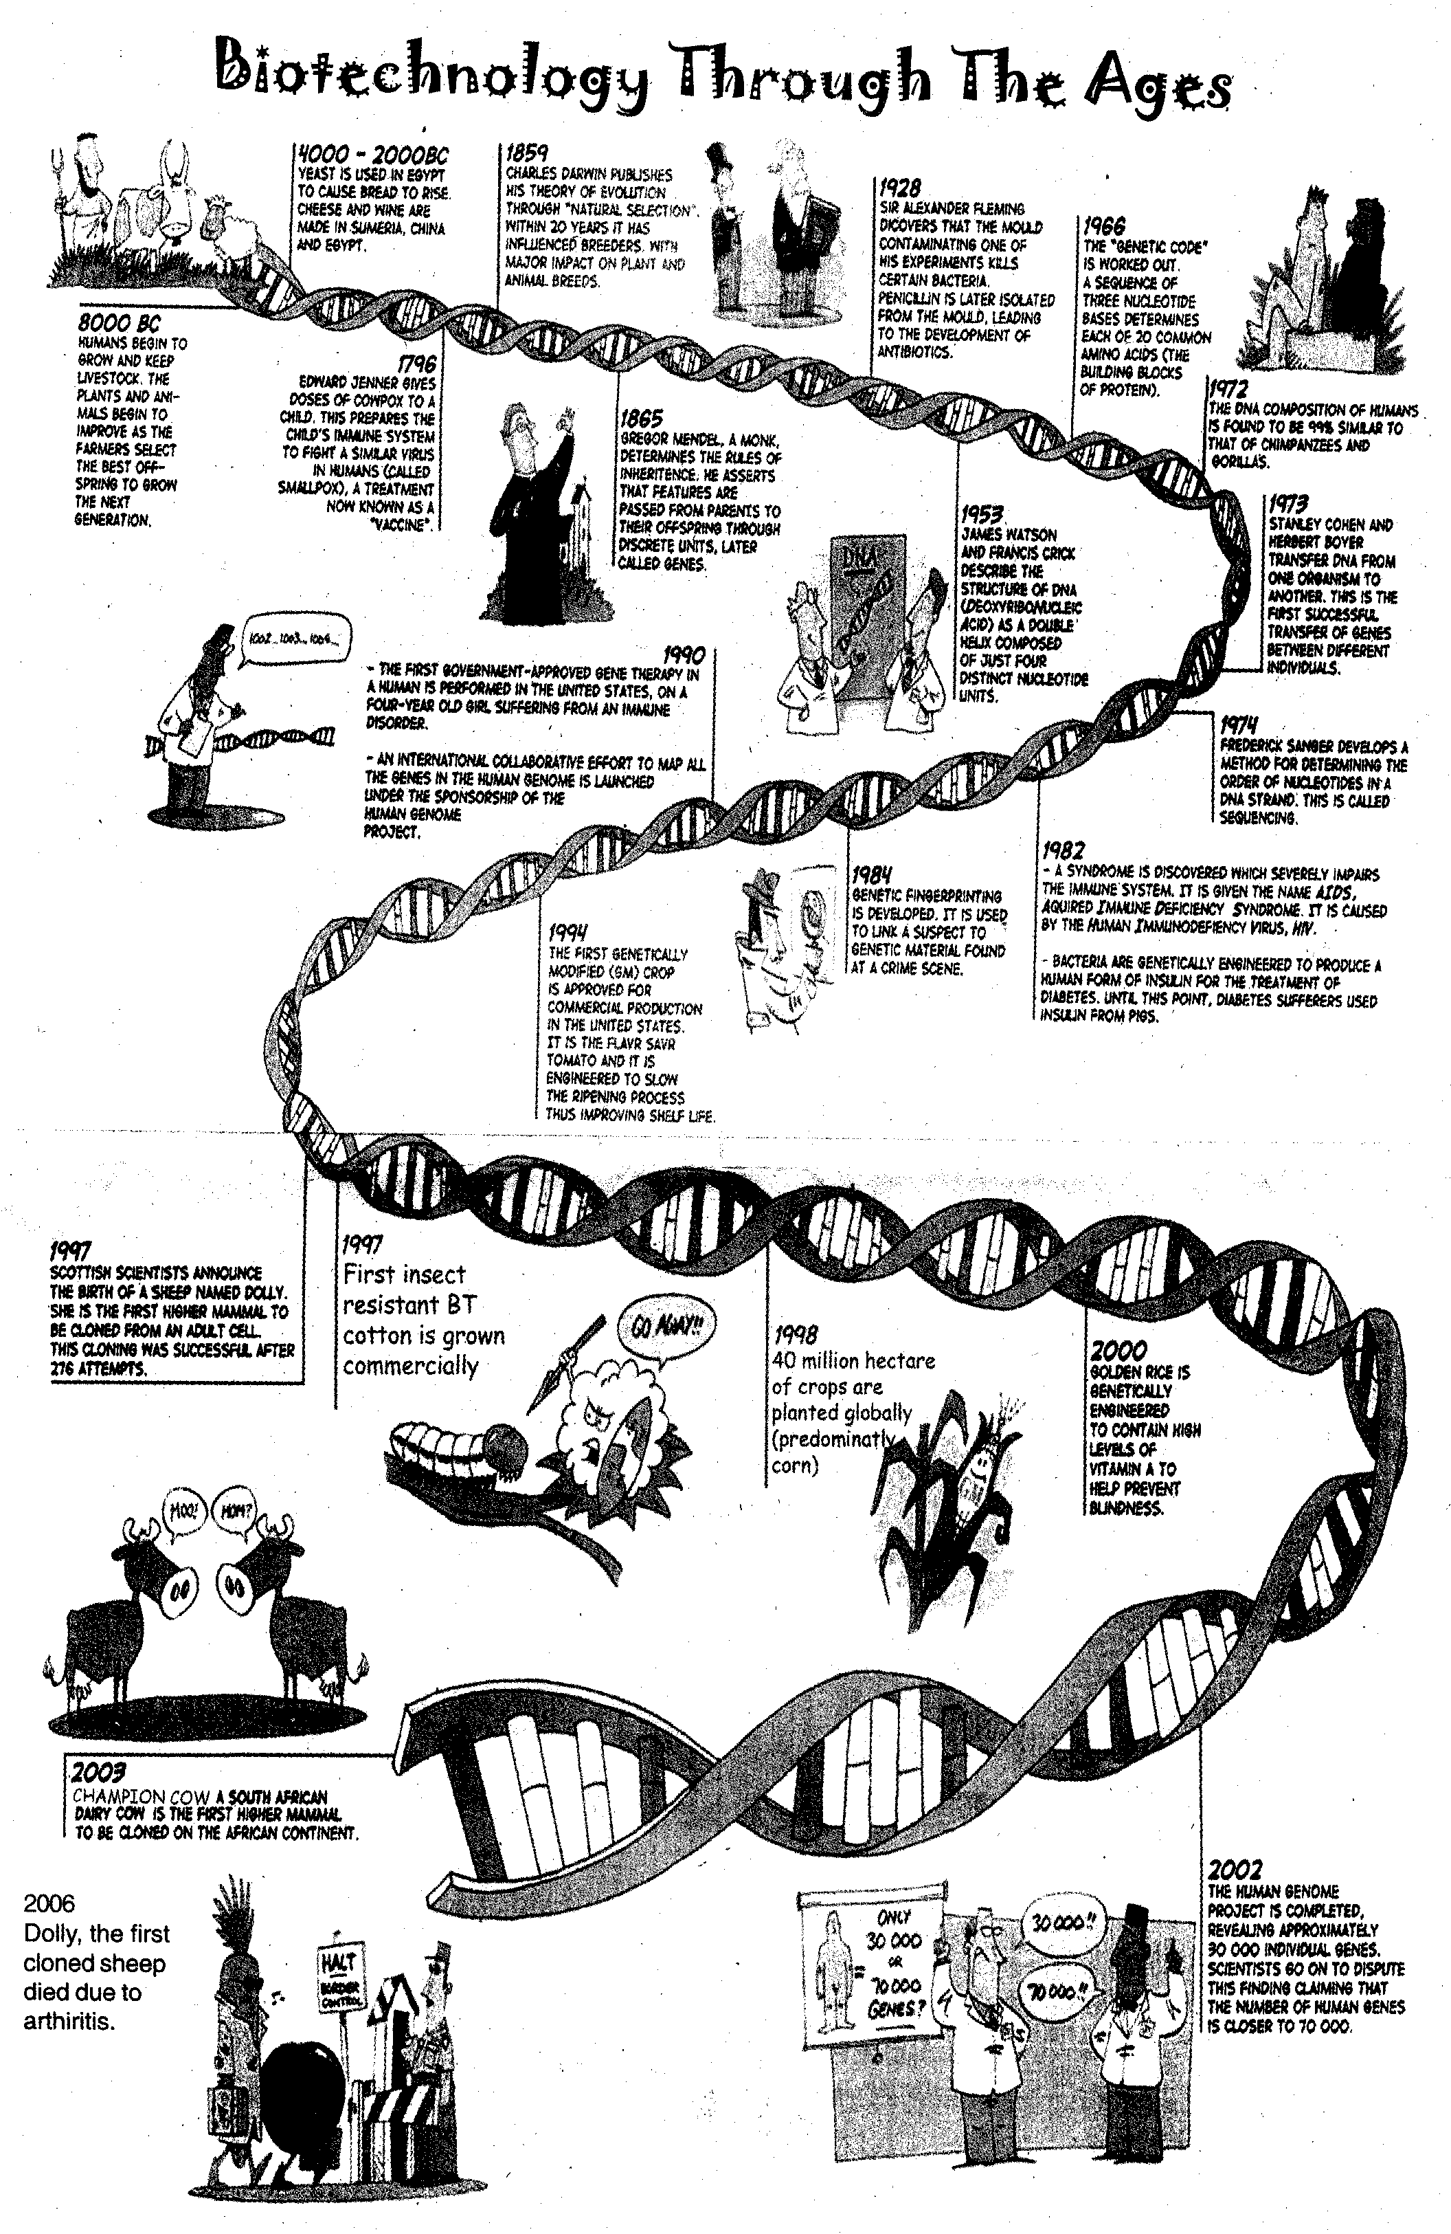
Botanically speaking the banana is an herb & the tomato is a fruit…
DEPT OF BIOTECHNOLOGY

